

Design Brief

## November 12, 2020

ANABENPASTRY.COM

Benny Daniel - Pastry Chef

BAntu - WEB Developer(HTML5, CSS3, JavaScript, Java)

Project Overview

What is the final deliverable of this project and what problem does this deliverable solve?

Ans:

Goals and Objectives:

what are we trying to achieve with this project — and by what date do we

want to accomplish that objective?

Ans:

# Target Audience:

As specifically as possible, who are we talking to? What are their defining demographic and psychographic characteristics?

Ans:

| Deliverable | Deadline | Hours to work(worked) | Budget $ |
| --- | --- | --- | --- |
| Registering Domain  (www.anabenpastry.com) |  | 1 | $250-$270 |
| Logo Designing | Done | 2 approx. |  |
| Gathering images | December 12 2020 | N/A | N/A |
| Writing on website(Good wording) | November 30 2020 | 3 |  |
| Coding by Bantu | Depends On Benny | Not known | Unlimited, Benny will Give Blank Check |

Company Profile

Company details (name, industry, products)

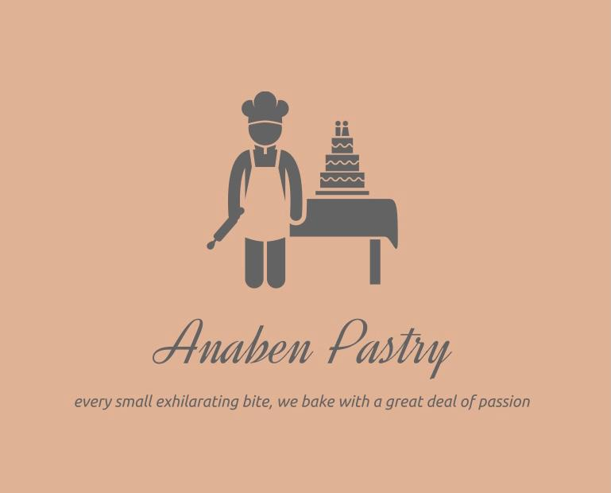

Brand mission, vision, and values